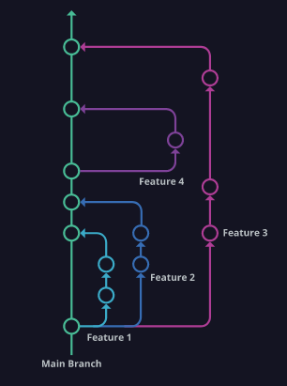https://www.gitkraken.com/learn/git/best-practices/git-branch-strategy.14/8/2022